Aaron Su

Caelen Coe

Noah Whelan

Mahamed Dirie

Rhea Chen

Valentina Valero

# **Preliminary Design**

### **Electrical System Schematic**

<Insert at end of lab>

**Technical Drawing**

**No major changes have been made since the previous Technical Drawing Section. Please refer to Concept Design section “Preliminary Technical Drawings” and figures 5-10 for all technical drawings.**

### **Digital Models**

Figure 2: Design 1, Isometric View of Parts

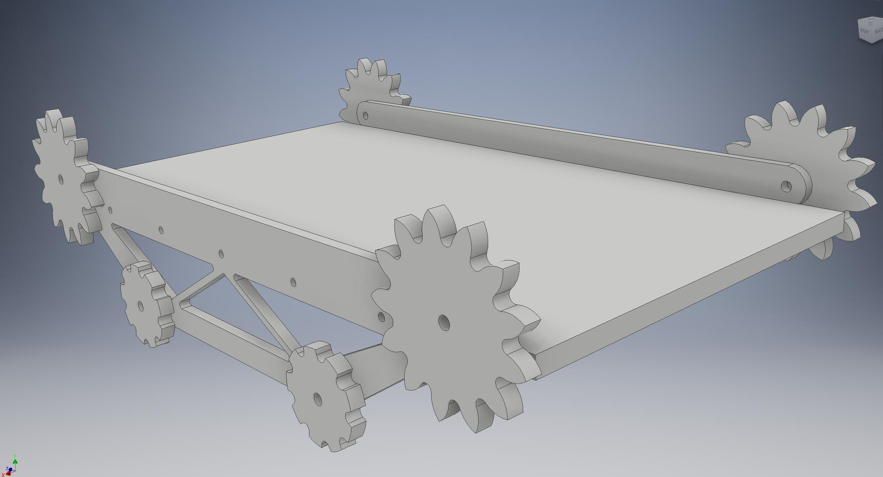

Figure 2: Design 2, Isometric View of Parts

Both designs are assembled and can be seen in Figure 1 for Design 1 and Figure 2 for Design 2. Design 1 and Design 2 will both take advantage of laser cutting when possible in order to save time and PLA material. This means the panels of the chassis, wheels (Design 1), supports for drive train (Design 1 and 2) and sprockets (Design 2) will all be laser cut. Smaller pieces, such as the axles in Design 1 and individual tracks on Design 2 will be 3D printed in order to be accurate and be made out of non-wood material.

Both designs use a simple chassis that is a rectangular box in order to conveniently have access to the electronic systems of the robot. In addition, the rectangular box is hollow in order to reduce weight, and leave room for the 1.5 kilogram weight that will be carried on board. The drive train will attach to the chassis in order to ensure the robot can be held together.

Design 1 takes advantage of wheels in order for the weight to be light and the frame to be rotatable in order to climb stairs. The front wheels are attached in order to maximize surface area contact with the stairs. Each wheel is also independently powered in order to allow “full-wheel drive” and generate torque when the wheels are in contact with any surface. The back wheel does not rotate since having all sets of wheels rotatable will make the robot unstable when climbing over multiple stairs. The back wheel is meant as an extra surface to ensure the robot will not fall backwards. This design will require an additional H-bridge, axles, and two motors in comparison to Design 2.

The files for Design one are specifically as follows:

Axel and Wheels

* Axel.ipt
* Front Wheel Base.ipt
* Rear Wheel Base.ipt
* Wheel Inner Ring.ipt
* Wheel Inner Spacer.ipt
* Wheel Main.ipt
* Wheel Outer Right.ipt

Vehicle Panels

* Vehicle Bottom Panel.ipt
* Vehicle Front Panel.ipt
* Vehicle Rear Panel.ipt
* Vehicle Side Panel.ipt

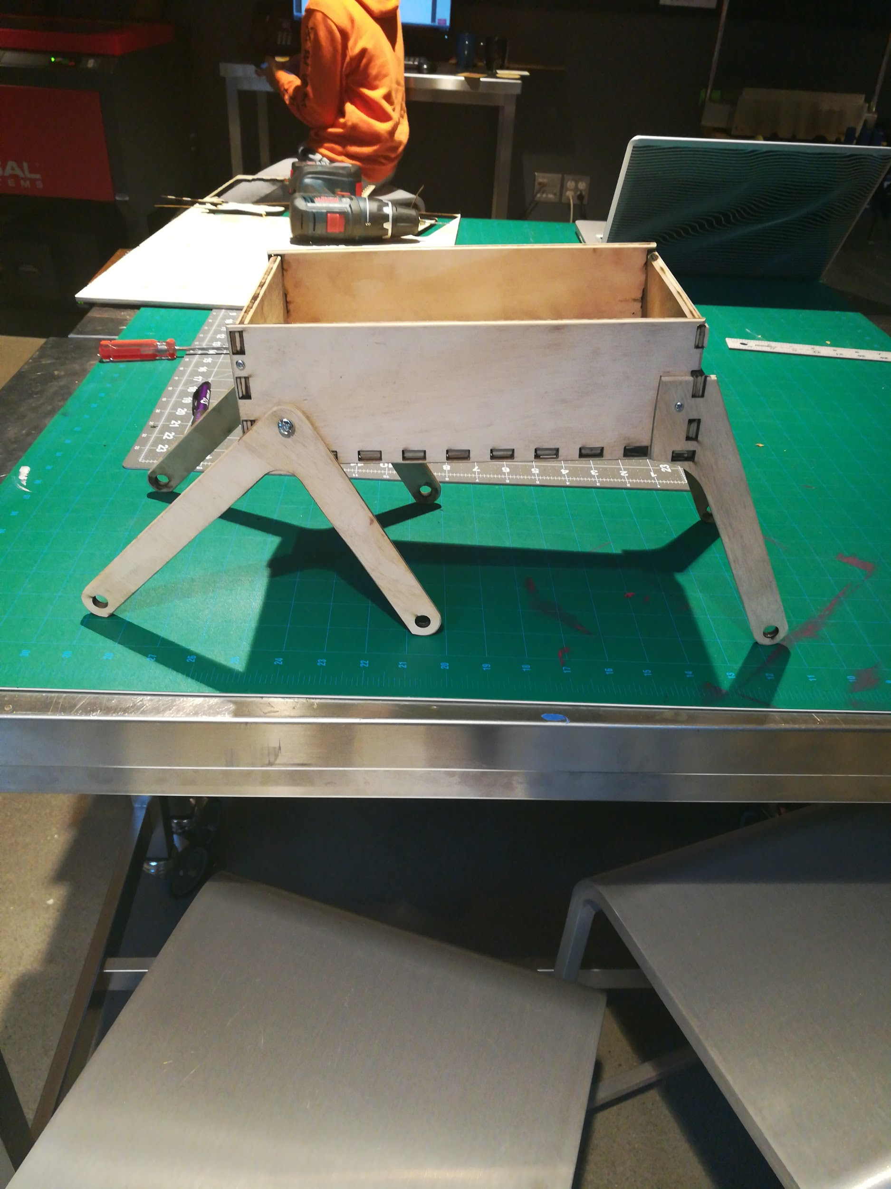

Figure 3: Design 1, Prototype Side View

In addition, a prototype cutout was made for Design 1 (Figure 3). This was cut out of birch wood to show that the design was technically feasible.

Design 2 is still in development, but Figure 2 shows a mostly completed CAD assembly. Design 2 mainly differs from Design 1 in that it will require more than 6 feet of track as opposed to 6 wheels. The track will be powered by 4 motors (2 on each side) in order to supply enough torque. The traction problem is also solved by having a continuous surface in contact with the stairs, albeit in a less flexible shape than Design 1. The gear design will also provide greater torque to the robot’s drivetrain since the speed will be reduced. Design 2 will require fewer electronics components (as stated above) but will require more material and potentially stronger motors in order to work.

### **Simple Machines**

Design 1 features a lever for the front 4 wheels and a wheel and axle for each of its 6 wheels. The second class lever will get its force from when the wheels apply a force to the stairs and the stairs push back. This will cause the level to rotate around the fulcrum, which is on the robot chassis, and allow the wheels to climb up the stairs and bring the robot with it. This is a simple machine since the force from the stairs pushing back moves the robot, causing work to be done. The wheel and axle machines found on each of the 6 wheels allow a motor to spin each wheel and axle at the same rate in order to cause the robot to drive. The wheel and axle are simple machines on this robot since they apply a force (from the motors) to move the robot and spin themselves. In combination with the lever on the front wheels, the robot will be able to climb stairs since the wheels can move the whole robot and the level will allow the robot to rotate in order to climb stairs.

Design 2 features gears that are used to power the tracks. The tracks will lay into the gears (of two different ratios) in order to supply maximum torque when the robot is climbing up the stairs. Torque is important in order to overcome gravity and climb up the stairs, meaning the gears are designed to be slow but powerful. It is a simple machine because it helps the robot apply a force coming from the motors against the ground in order to do work to get up the stairs.

The main reason there are two designs is so that we can test the functionality of these two simple machines. Design 1 uses more machines in order to increase the surface area and power applied to the surface through its lever and wheels. Design 2 uses gears to provide torque to the track, but has a smaller surface area by being unable to rotate. As both designs are tested, there will be much emphasis placed on how the design of the simple machines will affect the robot performance.

### **Updated Bill of Materials**

**No major changes have been made since the previous Updated Bill of Materials Section. Please refer to Concept Design section “Updated Bill of Materials” and “Table 1: Updated Bill of Materials Table”.**